Order Of Service

Singing: Psalm 84—CW page 96

Reading: Psalm 6

Opening Hymn: TLH 648

Reading: I Corinthians 7:1-11

Request Hymn: CW Supplement 735

Reading: Matthew 27:1-10

Sermon Hymn: TLH 409

Sermon Text: Luke 9:23-27

The Cost Of Discipleship

Prayer

The Apostles’ Creed, TLH page 12

Holy Communion

The Lord's Prayer

The Blessing

Closing Hymn: TLH 410

* * * * * * * * * * *

Bible Study: Lambs: Monarch Butterfly
Sheep: Proverbs 31:27-31
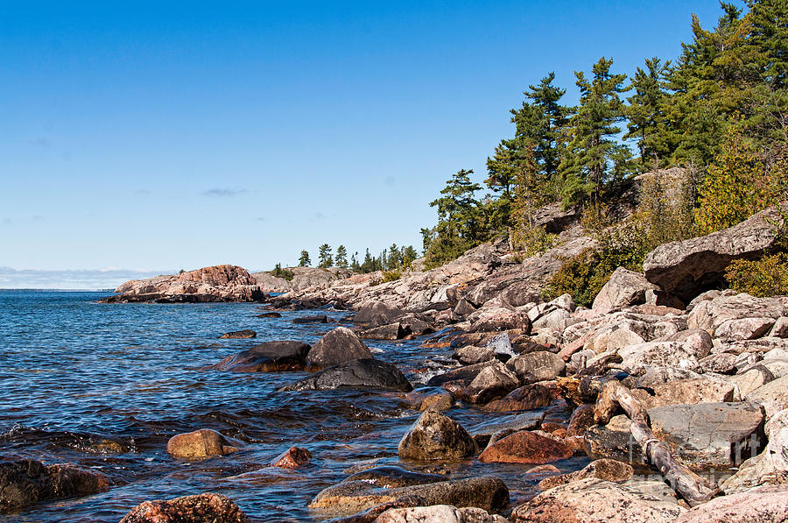

North Shore, Lake Superior

Water
Of
Life

26 September 2021

W A T E R O F L I F E

Independent Christian Church—Conservative Lutheran Doctrine

Worship Service: 9:30 a.m. Bible Study: 10:45 a.m.

Larry Cooper, Pastor E-Mail address:
111 N. Ridge Road lcooper@wateroflife.cc
Coon Valley, WI 54623 Web Site:
www.wateroflife.cc

* * * * * * * * * * * * * * * * * * * * * * * * * * *

Sermon Text: Luke 9:23-27

The Cost Of Discipleship

* * * * * * * * * * * * * * * * * * * * * * * * * * *

Luke 9:23 And he said to them all, If any man will come after me, let him deny himself, and take up his cross daily, and follow me.
:24 For whosoever will save his life shall lose it: but whosoever will lose his life for my sake, the same shall save it.
:25 For what is a man advantaged, if he gain the whole world, and lose himself, or be cast away?
:26 For whosoever shall be ashamed of me and of my words, of him shall the Son of man be ashamed, when he shall come in his own glory, and in his Father's, and of the holy angels.
:27 But I tell you of a truth, there be some standing here, which shall not taste of death, till they see the kingdom of God.

